Stem Cell Differentiation Using Surface Acoustic Waves

Matthew Wong

Department of Bioengineering, UC Berkeley

**Abstract:** Surface Acoustic Wave devices have the potential to measurably differentiate stem cells via interactions between the device substrate and cell membrane.

**Introduction:** Stem cells can help solve many medical and ecological dilemmas we face today. Lab grown meat can provide food to regions where there aren’t enough resources to raise animals, lab grown organs can solve organ shortages and limit people’s time in the hospital, etc. Stem cells differentiate based on several factors, one of which being physical forces applied to the cell membrane. Current methods of physically stimulated differentiation involve manual stimulation using micropipettes, a process that introduces a large amount of unwanted variation in a study where isolating variables is key.

Surface acoustic waves (SAWs) propagate along the surface of a piezoelectric substrate. Also known as Rayleigh waves, SAWs travel faster than bulk waves and are modified by objects it encounters during propagation. This property is especially useful in the testing of biological materials that aren’t static. Devices that utilize SAWs are commonly used as filters, oscillators, and transducers.

**Stem Cell Basics:** There are many different types of stem cells, but they all undergo two key processes: Replication and Differentiation. The latter refers to a stem cell’s ability to transform into another cell type (ranges from one to all cell types). Replication means the undifferentiated cell can divide into another version of itself, like mitosis in somatic cells. Embryonic stem cells have been in the media spotlight before concerning ethical use and derivation, but current stem cell research utilizes Induced Pluripotent Stem Cells. Derived from adult cells, IPSCs circumvent any ethical concerns and more importantly can be used to create tissue with a much lower rejection rate than tissues from donated organs. To harness the power of stem cells, researchers need to figure out exactly what factors cause them to differentiate into a specific cell type.

**Device Design:** The SAW device consists of a pair of Interdigitated Transducers (IDTs) that convert an AC sine signal to a Rayleigh wave. Using the Impulse Response model for SAWs, the acoustic finger spacing and width are found by the following equation (Wang, 2018 ):

Where *Vs* is the velocity of a SAW through the substrate and *f* is the desired operating frequency.

For the purposes of differentiation, the device should resonate at frequencies either lower or higher than the resonant frequency of the cell as vibrations that match resonant frequency may cause the cell to tear. For an example operating frequency of 200MHz, the calculated finger width and spacing is 3.98 micron.

The SAW device fabrication is done using the following MEMS techniques:

1. LPCVD of Polysilicon substrate
2. Spin on application of Photoresist
3. Pattern PR using IDT mask (Fig. 1)
4. Lift-off deposition of metal layer (Al or Au-Cr)

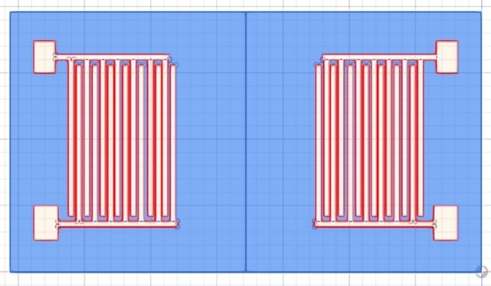

Fig. 1 IDT Mask

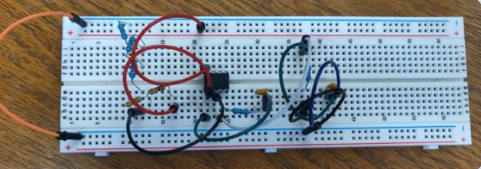**The Circuit:** The sine wave sent to the input transistor must also oscillate at the operating frequency of the IDT in order to have the strongest SAW and least amount of insertion loss. A Wein Bridge Oscillator is useful for this device as it can be easily constructed with minimal components and can output a sine wave of varying frequency. The circuit consists of 4 resistors, 2 capacitors, an op-amp, and a DC power supply (Fig. 2).

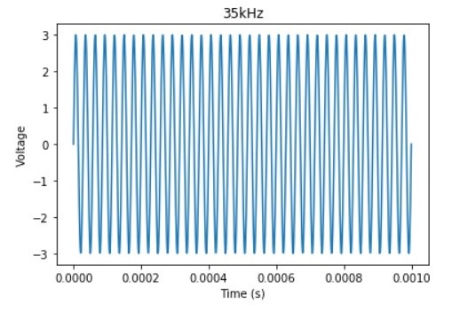

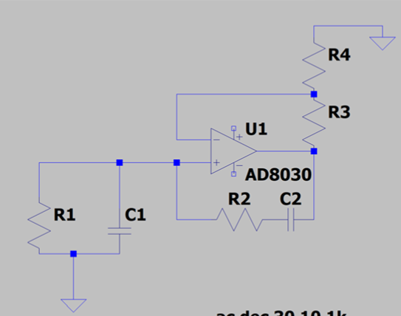

Fig. 2 Wein Bridge Oscillator

Output frequency of the circuit depends on the resonant behavior of the two RC components. The circuit also utilizes negative and positive feedback with the op-amp in such a way that the non-inverting and inverting voltages resonate according to the following equation where R is the resistor value and C is the individual capacitance:

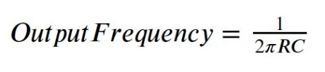

For the desired output of 200MHz, R = 795 $Ω$ and C = 1nF. A simulated circuit was evaluated with varying R and C values to produce the plots in Fig. 3. The magnitude of the output voltage is 1/3 of *Vin* and the phase shift at $\frac{1}{2\text{πRC}}$ is 0, another convenient aspect of the Wein Bridge Oscillator.

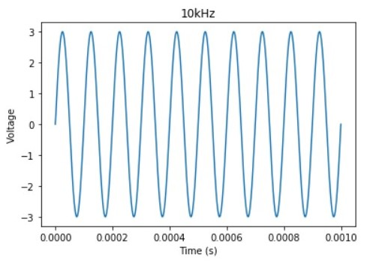

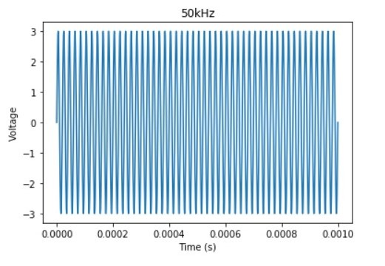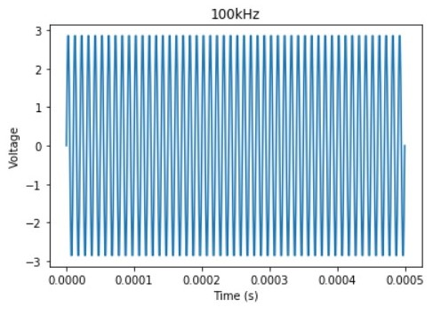

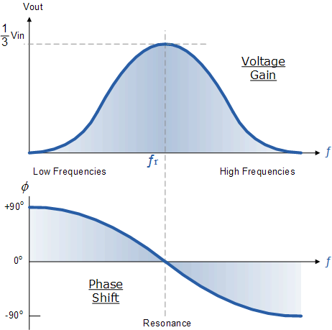Fig. 3 Frequency output from Wein Bridge Oscillator

Fig.4: Voltage Gain and Phase Shift of Wein Bridge Oscillator

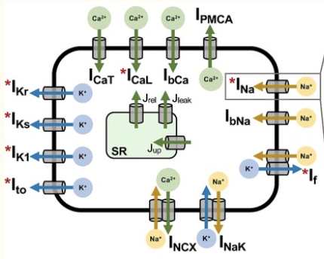**Biomaterial Interface:** For the SAW device to effectively manipulate a stem cell, the cell must be encapsulated in a biocompatible environment. Stem cells can spontaneously differentiate upon adhering to a surface. In order to mitigate early differentiation, our design employs a hydrogel to act as a makeshift extracellular matrix for the cell to absorb nutrients from and discard of waste products to. Hydrogels can hold magnitudes of order their weight in water which will prevent the cell from drying out (Gunkor-Ozkerim, 2018) A mix of 8% w/v Gelatin / 2% w/v HW Sodium Alginate hybrid gel has enough structural integrity to withstand vibration while securely holding the cell. In addition, the natural hydrogel is very biocompatible, as hybrid gels of this type have been used to create bioprinted Aortic valves (Duan, 2013)

In addition to adhesion, cell proliferation can also stimulate differentiation. To monitor the number of cells on the device, fluorescent markers will be added so real time cell counts will be possible. The added markers have been shown to have little to no effect on the differentiation process. If the number of cells present is above a chosen criterion, they will be manually removed.

**SAW-Cell Interactions:** Our study hypothesizes that the vibrations the cell is subjected to by the device cause the ion channels present in the lipid bilayer to become leaky. This will in turn change the ionic potential in the cell, which may trigger differentiation. In pluripotent stem cells, the ion channels seen in Fig. 6 would be most affected by our device. However, since most of the channels are time dependent and not widely researched, the Hodgkin-Huxley

Fig 6: (Above) Ion channels of cell. (Below) Hodgkins-Huxley model of stem cell

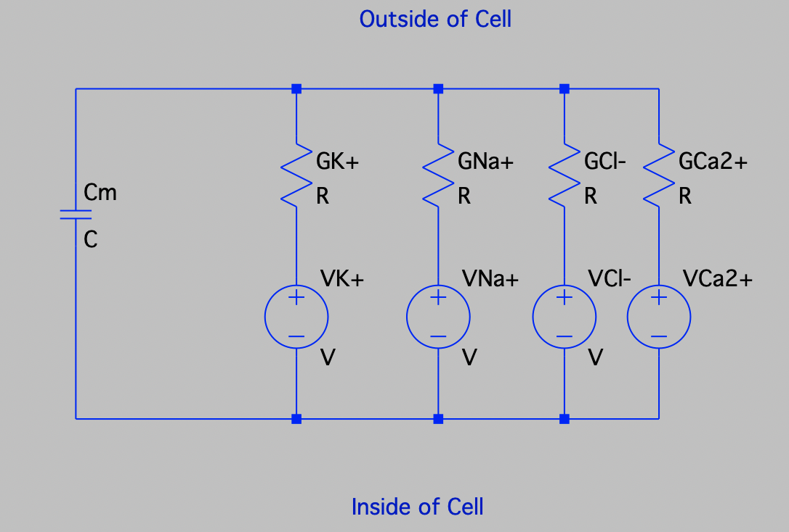model created only considers the Na+, K+, Cl-, and Ca2+ channels (Fig.6)

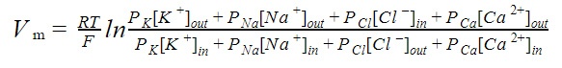Using the Goldman-Hodgkin-Katz equation below,

voltage across the membrane can be determined. Values taken from Table 1 (Kernik,2019) and inserted into the GHK equation find a membrane potential of -43.53mV.

|  |  |  |  |
| --- | --- | --- | --- |
| Ion species (S) | [S] out  (mM) | [S] in  (mM) | Ratio of Permeability [S] |
| Na+ | 150 | 5 | 0.03 |
| K+ | 5.4 | 150 | 1.0 |
| Cl- | 159 | 159 | 0.1 |
| Ca2+ | 1.8 | 4 | 0.177 |

Table.1

Promising results from Tufts University show that changes in membrane potential influence the timing and rate of differentiation (Sundelacruz, Levin, Kaplan, 2008). The membrane potential of differentiating cell has experimentally been shown to fluctuate around -90mV. This means that for our device to differentiate a stem cell, a frequency that results in a -90mV membrane potential will be optimal.

**Medical Applications:** The stem cell’s ability to replicate and differentiate is exactly why it is so promising to the future of medicine. Degenerative diseases are currently treated with transplantation of cells, blood transfusions, or organ replacements. Tissue rejection, incompatibility, and immunologic barriers are issues cell therapy has yet to solve. Stem cells derived from a patient’s own tissue is a way to mitigate these problems. 3D bioprinting of stem cell infused organ scaffolds is an area of current research that will provide custom organs to the 113,245 patients on the UNOS waiting list. (UNOS, 2019)

**Future Direction:** The SAW device is versatile and cheap to produce with current MEMS technology. However, it’s limited in terms of multiple use as cleaning the device might damage the IDTs as well as the substrate. A future improvement could also be to the IDT design. A new geometry that allows for low frequency waves while still maintaining sub mm size would mean individual stem cells could still be analyzed at low frequencies. The current IDT design has 10kHz SAW produced on magnitudes of order larger devices. Future iterations of this design will no doubt uncover more insight into stem cell differentiation.

**References:**

Ziping Wang, Xian Xue, Xingjia Li, Zhengxuan Jiang, and Karthik Reddy. “Standing Wave Performance Test of IDT-SAW Transducer Prepared by Silk-Screen Printing.” AIP Advances, vol. 8, no. 5, 2 May 2018, doi:10.1063/1.5033349.

Gungor-Ozkerim, P Selcan et al. “Bioinks for 3D bioprinting: an overview.” Biomaterials science vol. 6,5 (2018): 915-946. doi:10.1039/c7bm00765e

Duan, Bin et al. “3D bioprinting of heterogeneous aortic valve conduits with alginate/gelatin hydrogels.” Journal of biomedical materials research. Part A vol. 101,5 (2013): 1255-64. doi:10.1002/jbm.a.34420

Kernik, Divya C et al. “A computational model of induced pluripotent stem-cell derived cardiomyocytes incorporating experimental variability from multiple data sources.” The Journal of physiology vol. 597,17 (2019): 4533-4564. doi:10.1113/JP277724

“Wien Bridge Oscillator Tutorial and Theory.” *Basic Electronics Tutorials*, Aspencore, 21 Feb. 2018, www.electronics-tutorials.ws/oscillator/wien_bridge.html.